Nombre: __________________________ Bloque: ____________ Fecha: ______________________
Español 1 – Examen Final – Guía de estudio
1. Temas:
- Conjugating –AR, -ER, -IR verbs in the present tense along with common irregulars (ir, ser, querer, tener, estar, dar, etc.)
- Be able to introduce yourself and others, describe yourself and others, and say where you and others are from.
- Say what classes you have, describe your classes and say what time you have those classes.
- Give dates, birthdays, and ages and tell time.
- Tell activities that you/people do/did in the present tense and preterite (at home, in class/school, at the park, at the beach, etc.)
- Say what you and others like and don’t like, and like and don’t like to do.
- Stem-changing verbs (e-ie, e-i, o-ue, u-ue)
- Direct object pronouns
- Talk about what clothing you buy and wear and in what seasons.
- Talk about wants and preferences
- Talk about places to go and activities to do around the city, including transportation.
- Describe what you do, order, and what is served at a restaurant or café.
- Irregular Yo verbs (dar and –GO verbs)
- Affirmative Tú Commands
- Ser vs Estar
- Talk about the layout and rooms of a house and the furniture and items in the house.
- Talk about planning a surprise birthday part.
- Talk about the chores you and others do.
- Talk about summer and beach activities.
- Talk about sports and sports equipment/activities.
- Tell about injuries and health and if something hurts.
- Saber vs. Conocer + personal “a”
- Conjugating Jugar and Doler
- Use the preterite tense of –AR verbs and –car/-gar/-zar verbs.
- Culture of Ecuador, Spain, & Dominican Republic

2. Partes del examen:
Speaking Test Section – 25%
For the speaking test you will receive a prompt in Spanish asking you to respond to a series of questions or provide specific information related to the themes covered in this unit. Your teacher will read the questions to you and you will respond in complete, detailed sentences in Spanish. You will be graded on the speaking rubric.

Listening Test Section – 25%
For the listening test, you will hear various styles of listening samples in Spanish related to the vocabulary and grammar from this unit. These samples can range from conversations, advertisements, sentences, and monologues to completing dictations. Then you will have to answer comprehension questions about what you heard. These questions may be true or false statements, fill-in-the-blank statements, short answer questions, or multiple-choice questions. The listening sections will be similar to what we have practiced in class.

Reading/Vocabulary Test Section – 25%
For the reading test, you will have to read various styles of reading samples in Spanish related to the vocabulary and grammar from this unit. These samples can range from written conversations, advertisements, sentences, and paragraphs to short stories. Then you will have to answer comprehension questions about what you heard. These questions may be true or false statements, fill-in-the-blank statements, short answer questions, true/false, or multiple-choice questions. The reading sections will be similar to what we have practiced in class and/or to the readings found in the book and workbook. You should also review the vocabulary list from the current unit and the notes from the current unit in preparation.

Writing Test Section – 25%
For the writing test, you will need to respond in Spanish to a given prompt. You may be asked to write an essay, write a short story, write a letter, create a written conversation, or provide another similar type of written piece. You should be prepared to write in essay form including an introduction, a conclusion, detailed supporting information, and you should make sure to have multiple, indented paragraphs. You will be graded on the writing rubric.

3. Speaking/Writing Practice/Focus Questions:
Make sure you can (Speaking/Writing):
- Describe yourself & others & say where you are from
- Give dates, birthdays, & ages
- Tell what classes you have, describe your schedule, & what you do in class/school
- Say what things you and others like, don’t like, like to do, and don’t like to do
- Say what you eat and drink for meals
- Say what clothes you and others are wearing and describe the clothing
- Say what rooms are in your house, and what furniture is in each room.
- Say what you and others do for chores or to prepare for an event
- Say what sports you play and describe sporting events and equipment
- Talk about going to the beach (in the past) and items you need.
- Say what you did in both the present tense and the preterite tense.

Speaking/Writing Questions to Practice:
- ¿Cómo te llamas?
- ¿Cómo estás?
- ¿Cómo eres? [Physical looks & personality]
- ¿Quiénes son y cómo son tus amigos?
- ¿De dónde eres? ¿Dónde vives?
- ¿Cuántos años tienes?
- ¿Cuándo es tu cumpleaños?
- ¿Cuál es tu clase favorita?
- ¿Qué clases tienes y qué haces durante las clases?
- ¿Qué te gusta hacer? ¿Qué no te gusta hacer?
- ¿Qué les gusta hacer a tus amigos?
- ¿Qué ropa llevas hoy?
- ¿Qué comes y bebes por almuerzo? ¿Qué te gusta comer y beber?
- ¿Qué deportes juegas? ¿Qué deportes te gustan?
- ¿Cómo es tu casa? ¿Qué cuartos hay en tu casa?
- ¿Qué quehaceres haces en tu casa?
- ¿Qué haces en la playa? [Answer in present tense]
- ¿Qué hiciste [did you do] en la playa el verano pasado? [Answer in preterite]
- ¿Jugaste al fútbol o al voleibol? ¿Caminaste en el parque?
- ¿Qué necesitaste para ir a la playa?

4. Vocabulario:
El centro comercial | Shopping center; mall | El cine | Movie theater; the movies
¿Cuánto cuesta(n)? | How much does it (they) cost? | El parque | The park
Cuesta(n)… | It (they) cost… | El restaurante | Restaurant
El dinero | Money | El teatro | The theater
El dólar | Dollar | El concierto | Concert
El euro | Euro | Las entradas | Tickets
Ir de compras | To go shopping | La música rock | Rock music
Pagar | To pay | La película | Movie
El precio | The price | La ventanilla | Ticket window
La tienda | Store | A pie | By/on foot
La blusa | Blouse | La calle | Street
Los calcetines | Socks | En autobús | By bus
La camisa | Shirt | En coche | By car
La camiseta | T-shirt | Encontrar (oue) | To find
La chaqueta | Jacket | Tomar | To take
Feo(a) | Ugly | El (la) camarero(a) | (Food) server; waiter
El gorro | Winter hat | Costar (oue) | To cost
Los jeans | Jeans | La cuenta | The bill
Llevar | To wear | De postre | For dessert
Nuevo(a) | New | El menú | Menu
Los pantalones | Pants | La mesa | Table
Los pantalones cortos | Shorts | El plato principal | The main course
La ropa | Clothing | La propina | Tip
El sombrero | Hat | Pedir (ei) | To order; to ask for
El vestido | Dress | Servir (ei) | To serve
Los zapatos | Shoes | El arroz | Rice
Amarillo(a) | Yellow | El bistec | Beef; steak
Anaranjado(a) | Orange | El brócoli | Broccoli
Azul | Blue | La carne | Meat
Blanco(a) | White | La ensalada | Salad
Marrón (marrones) | Brown | Los frijoles | Beans
Negro(a) | Black | El pastel | Cake
Rojo(a) | Red | La patata; la papa | Potato
Verde | Green | El pescado | Fish
Tener calor | To be hot (how a person feels) | El pollo | Chicken
Tener frío | To be cold (how a person feels) | El tomate | Tomato
Tener razón | To be right | Las verduras | Vegetables
Tener suerte | To be lucky | Allí | There
La estación (las estaciones) | Season | Almorzar (oue) | To eat lunch
El invierno | Winter | Aquí | Here
El otoño | Autumn; fall | Dormir (oue) | To sleep
La primavera | Spring | El lugar | The place
El verano | Summer | Poder (oue) | To be able; can
Durante | During | Tal vez | Perhaps; maybe
Cerrar (eie) | To close | Ver | To see
Empezar (eie) | To begin | Volver (oue) | To return; to come back
Entender (eie) | To understand | Morado(a) | Purple
Pensar (eie) | To think; to plan | Rosado(a) | Pink
Preferir (eie) | To prefer | Allá | Over there
Querer (eie) | To want | Hace calor | It’s hot (weather)
El café | Café | Hace frío | It’s cold (weather)
El centro | Center; downtown | Jugar (uue) | To play

El apartamento | Apartment | Decorar | To decorate
El armario | Closet; armoire | La fiesta de sorpresa | Surprise party
Bajar | To descend | El globo | Balloon
La casa | House | Los invitados | Guests
La cocina | Kitchen | Invitar a | To invite (someone)
El comedor | Dining room | Salir | To leave; to go out
El cuarto | Room; bedroom | El secreto | Secret
La escalera | Stairs | Venir | To come (to a place)
Ideal | Ideal | Abrir | To open
El jardín (los jardines) | Garden | Buscar | To look for
El patio | Patio | Envolver (o-ue) | To wrap
El piso | Floor (of a building) | El papel de regalo | Wrapping paper
La planta baja | Ground floor | Recibir | To receive
La sala | Living room | El regalo | Gift; present
Subir | To go up | Traer | To bring
El suelo | Floor (of a room) | Acabar de… | To have just…
La alfombra | Rug | Ayudar | To help
La cama | Bed | Barrer el suelo | To sweep the floor
La cómoda | Dresser | Cocinar | To cook
Las cortinas | Curtains | Cortar el césped | To cut the grass/mow the lawn
El espejo | Mirror | Darle de comer al perro | To feed the dog
La lámpara | Lamp | Deber | Should; ought to
Los muebles | Furniture | Hacer la cama | To make the bed
El sillón (los sillones) | Armchair | Lavar los platos | To wash the dishes
El sofá | Sofa; couch | Limpiar (la cocina) | To clean (the kitchen)
La cosa | Thing | Limpio(a) | Clean
El disco compacto | Compact disc | Pasar la aspiradora | To vacuum
El lector DVD | DVD player | Planchar la ropa | To iron clothes
El radio | The radio | Poner la mesa | To set the table
El televisor | Television set | Los quehaceres | Chores
El tocadiscos compactos | CD player | Sacar la basura | To take out the trash
Los videojuegos | Video games | Sucio(a) | Dirty
Primero(a)/Primer/ (1˚/1 ª) | First (1st) | Decir | To say; to tell
Segundo(a)/ (2˚/2 ª) | Second (2nd) | Hay que | One has to; one must
Tercero(a)/Tercer / (3˚/3 ª) | Third (3rd) | Poner | To put; to place
Cuarto(a) / (4˚/4 ª) | Fourth (4th) | Si | If
Quinto(a) (5˚/5 ª) | Fifth (5th) | Todavía | Still; yet
Sexto(a) / (6˚/6 ª) | Sixth (6th) | El dormitorio; la habitación | Bedroom
Séptimo(a) / (7˚/7 ª) | Seventh (7th) | El cuarto de baño | The bathroom
Octavo(a) / (8˚/8 ª) | Eighth (8th) | El garaje | Garage
Noveno(a) / (9˚/9 ª) | Ninth (9th) | Las escaleras | Stairs
Décimo(a) / (10˚/10 ª) | Tenth (10th) | El telefóno celular (Lat. Amer) | Cellphone
Bailar | To dance | El teléfono móvil (Spain) | Cellphone
Cantar | To sing | El celular (Lat. America) | Cell
Celebrar | To celebrate | El móvil (Spain) | Cell
Dar una fiesta | To give/throw a party | La puerta | The door
Las decoraciones | Decorations

El básquetbol | Basketball | La piel | Skin
El béisbol | Baseball | La pierna | Leg
El fútbol americano | Football | La rodilla | Knee
Nadar | To swim | El tobillo | Ankle
La natación | Swimming | El bolqueador de sol | Sunscreen
Patinar | To skate | Bucear | To scuba-dive
Patinar en línea | To in-line skate | Caminar | To walk
El tenis | Tennis | Hacer esquí acuático | To water-ski
El voleibol | Volleyball | El mar | The sea
El bate | Bat | La playa | The beach
El casco | Helmet | Tomar el sol | To sunbathe
El guante | Glove | Doler (o-ue) | To hurt; to ache
Los patines en línea | In-line skates | Lo siento. | I’m sorry
La pelota | Ball | Anoche | Last night
La raqueta | Racket | Ayer | Yesterday
Comprender las reglas | To understand the rules | Comenzar (e-ie) | To begin; to start
Favorito(a) | Favorite | Terminar | To end; to finish
Ganar | To win | ¿Qué hiciste (tú)? | What did you do?
El partido | Game; match | ¿Qué hicieron ustedes? | What did you (plural) do?
Peligroso(a) | Dangerous | El fútbol | Soccer
Perder (e-ie) | To lose | Patear | To kick
Los aficionados | Fans | Lanzar; tirar | To throw
El (la) atleta | Athlete | El tanto | The point; the score
El campéon (los campeones), la campeona | Champion | Empatado(a) | Tied
El campo | Field | La portería | The goal (soccer)
La cancha | Court | El balón | Ball (often a larger one for volleyball, soccer, basketball)
El equipo | Team | La pelota | Ball (can be used for all balls including baseball or tennis)
El estadio | Stadium | El (la) bateador(a) | Batter
El (la) ganador(a) | Winner | El lanzador | Pitcher
El (la) jugador(a) | Player | El receptor | Catcher
La piscina | Pool | El jardinero | Outfielder
Enfermo(a) | Sick | La base | Base
Fuerte | Strong | Batear | To bat
Herido(a) | Hurt | Atrapar | To catch
Levantar pesas | To lift weights | Pasar | To pass
La salud | Health | Driblar | To dribble
Sano(a) | Healthy | Encestar | To make a basket
La boca | Mouth | La canasta | The basket
El brazo | Arm | La muñeca | Wrist
La cabeza | Head | Los dedos | Fingers
El corazón (los corazones) | Heart | Los dedos de pie | Toes
El cuerpo | Body | El traje de baño | Bathing suit
El estómago | Stomach | Los anteojos de sol | Sunglasses
La mano | Hand | La toalla playera | Beach towel
La nariz (las narices) | Nose | La red | The net (tennis)
El ojo | Eye | Golpear la pelota | To hit the ball
La oreja | Ear | La arena | The sand
El pie | Foot | Me duele…. | My …. hurts me.

5. Gramática:
- -AR Verbs:
Yo -o | Nosotros(as) -amos
Tú -as | Vosotros(as) –áis
Usted -a  Él/ella -a | Ustedes -an  Ellos/ellas -an

- -ER Verbs:
Yo -o | Nosotros(as) -emos
Tú -es | Vosotros(as) –éis
Usted -e  Él/ella -e | Ustedes -en  Ellos/ellas -en

- -IR Verbs:
Yo -o | Nosotros(as) -imos
Tú -es | Vosotros(as) –ís
Usted -e  Él/ella -e | Ustedes -en  Ellos/ellas -en

- Verbos irregulares/Boot Verbs: Dormir: oue, Poder: oue, Volver: oue, Devolver: oue, Almorzar: oue, Costar: oue, Encontrar: oue, Jugar: uue, Empezar: eie, Comenzar: eie, Querer:eie, Preferir: eie, Perder: eie, Cerrar: eie, Entender: eie, Tener: eie, Venir: eie, Pedir: ei, Servir: ei, Decir: ei

Dormir – To Sleep - oue  - Duermo - Dormimos  - Duermes - Dormís  - Duerme - Duermen  Empezar – To Begin- eie  - Empiezo - Empezamos  - Empiezas - Empezáis  - Empieza - Empiezan  Querer – To Want - eie  - Quiero - Queremos  - Quieres - Queréis  - Quiere - Quieren  Servir – To Serve, ei  - Sirvo - Servimos  - Sirves - Servís  - Sirve - Sirven | Poder – To Be able to - oue  - Puedo - Podemos  - Puedes - Podéis  - Puede - Pueden  Jugar – To Play - uue  - Juego - Jugamos  - Juegas - Jugáis  - Juega - Juegan  Perder – To Lose - eie  - Pierdo - Perdemos  - Pierdes - Perdéis  - Pierde - Pierden  Pedir – To Order - ei  - Pido - Pedimos  - Pides - Pedís  - Pide - Piden

Direct Object Pronouns:
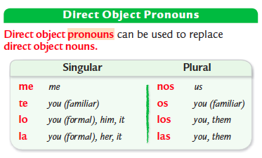

- Ser:
Yo soy | Nosotros(as) somos
Tú eres | Vosotros(as) sois
Usted es  Él/ella es | Ustedes son  Ellos/ellas son

- Estar:
Yo estoy | Nosotros(as) estamos
Tú estás | Vosotros(as) estáis
Usted está  Él/ella está | Ustedes están  Ellos/ellas están

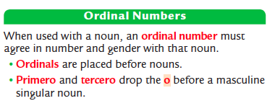
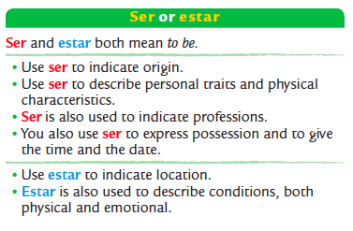

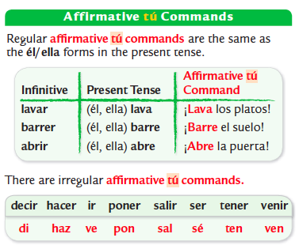
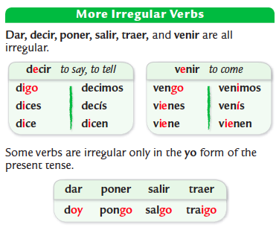
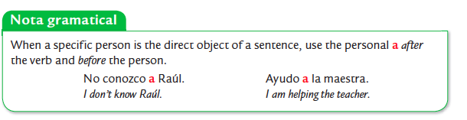
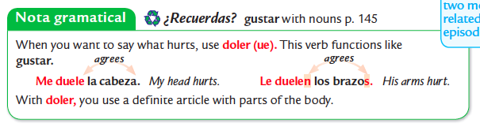

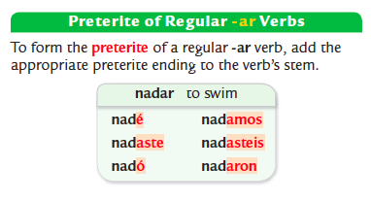
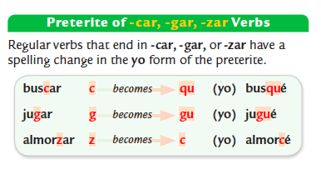

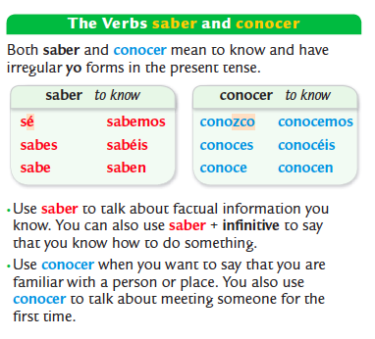
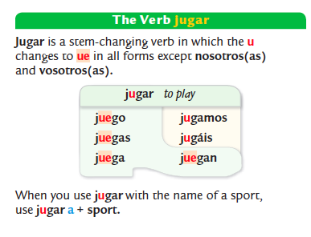

6. Cultura:
Please review your notes sheet on the cultural topics. While culture is not on the exam itself, this is a review of the important topics we covered.

Información general:
- The capital of Spain/España is Madrid
- Some typical foods of Spain are paella, tortilla española and gazpacho
- Spain’s currency is the euro.

Sevilla, las sevillanas y el flamenco:
- Sevillanas are similar to flamenco, which involves singing, dancing, guitar playing, along with rhythmic foot taps and clapping.
- Girls wear el traje sevillana or a traditional costume during Feria de Abril, which takes place in Sevilla, España.

El fútbol:
- Two soccer teams from Spain are Read Madrid & their rival team FC Barcelona or El Barça.

El arte surrealista:
- Salvador Dalí is a famous artist from Spain known for his surrealist paintings.
- Surrealist paintings reflect an artist's imagination and are often inspired by dreams and imagination.

Información general:
- Quito is the capital of Ecuador.
- Ecuador is on the continent of South America.
- Ecuador is located on the line of the equator, from which it gets its name.

The Andes Mountains & Cotopaxi Volcano:
- The world's highest active volcano is Cotopaxi near Quito, Ecuador.
- The Andes mountain range stretches north to south along the western coast of South America.

Geographic Sites & the Equator:
- The equator devices the northern and southern hemispheres.
- The monument, La Mitad del Mundo (The Middle of the World) in Ecuador, marks the location of equator, where you can stand in both hemispheres.

Información general:
- Santo Domingo is the capital of the Dominican Republic.
- The Dominican Republic shares the island of Hispaniola (La Española) with the country of Haiti.
- Casabe (Cazabe) is a type of Dominican food. It is a flat bread made from cassava or yucca flour.

Baseball:
- Baseball is the Dominican Republic's national sport.
- The Serie del Caribe or Caribbean Series is a baseball competition where winter league championship teams from four countries compete.

Altar de la Patria:
- The Altar de la Patria or Altar of the Nation is a memorial located in the city of Santo Domingo
- The Altar de la Patria is a memorial dedicated to the heroes of the Dominican Republic's fight for independence.

El Festival del Merengue:
- Merengue is a lively style of music and dance that many consider a symbol of the Dominican Republic.
- Instruments such as güiro, maracas, accordion, saxophone, and drums to play merengue's characteristic rhythm.
- The Festival del Merengue takes place in Santo Domingo every summer.

