Nombre: __________________________ Bloque: ____________ Fecha: ______________________
Español 2 – Unidad 3 – Guía de estudio
1. Temas:
- Discuss shopping for clothing, jewelry, shoes, and handicrafts.
- Discuss what items are made out of and be able to have a conversation in a market.
- Verbs like gustar (me encanta, me interesa, me importa, me queda)
- Irregular yo verbs in the present tense (pongo, hago, vengo, salgo, digo, traigo, veo, conozco, sé, etc).
- Hace que & time words with present and preterite tenses
- Preterite stem-changing verbs (e->i, o->u) (pedir, servir, preferir, competir, seguir, vestirse)
- Irregular preterite verbs (tuve, estuve, pude, puse, supe, hice, etc).

2. Partes del examen:
Listening Test Section – 25%
For the listening test, you will hear various styles of listening samples in Spanish related to the vocabulary and grammar from this unit. These samples can range from conversations, advertisements, sentences, and monologues to completing dictations. Then you will have to answer comprehension questions about what you heard. These questions may be true or false statements, fill-in-the-blank statements, short answer questions, or multiple-choice questions. The listening sections will be similar to what we have practiced in class.

Reading/Vocabulary Test Section – 25%
For the reading test, you will have to read various styles of reading samples in Spanish related to the vocabulary and grammar from this unit. These samples can range from written conversations, advertisements, sentences, and paragraphs to short stories. Then you will have to answer comprehension questions about what you heard. These questions may be true or false statements, fill-in-the-blank statements, short answer questions, true/false, or multiple-choice questions. The reading sections will be similar to what we have practiced in class and/or to the readings found in the book and workbook. You should also review the vocabulary list from the current unit and the notes from the current unit in preparation.

3. Vocabulario:
Unit 3
El abrigo | Coat | Los artículos | Goods
Las botas | Boots | Barato(a) | Inexpensive; cheap
El chaleco | Vest | La escultura | Sculpture
El cinturón | Belt | Fino(a) | Fine
La falda | Skirt | Una ganga | A bargain
La gorra | Cap; hat | La pintura | Painting
La pulsera | Bracelet | El retrato | Portrait
El reloj | Watch; clock | Único(a) | Unique
Las sandalias | Sandals | (Estar) hecho(a) a mano | (To be) handmade
El suéter | Sweater | Ser de… | To be made of…
El traje | Suit | Cerámica | Ceramic
De cuadros | Plaid | Cuero | Leather
De rayas | Striped | Madera | Wood
Estar de moda | To be in style | Metal | Metal
El número | Shoe size | Oro | Gold
La talla | Clothing size | Piedra | Stone
Vestirse (e-i) | To get dressed | Plata | Silver
¿Cómo me queda(n)? | How does it (they) fit me? | Con mucho gusto | With pleasure
Quedar… | To fit… | Con permiso | Excuse me
Bien | Well | De nada | You’re welcome
Mal | Badly | Disculpe | Excuse me; I’m sorry
Flojo(a) | Loose | No hay de qué | Don’t mention it
Apretado(a) | Tight | Pase | Go ahead
El almacén | Department store | Perdóneme | Forgive me
La farmacia | Pharmacy | ¿Me deja ver…? | May I see…?
Internet | Internet | Pedir (e-i) | To ask for; to order
La joyería | Jewelry store | Competir (e-i) | To compete
La librería | Book store | Seguir (e-i) | To follow
La panadería | Bakery | Preferir (e-i) | To prefer
La zapatería | Shoe store | Servir (e-i) | To serve
Está abierto(a) | It’s open | Vestirse (e-i) | To get dressed
Está cerrado(a) | It’s closed | Dormir (o-u) | To sleep
Creo que sí. | I think so. | Estar (estuv-) | To be
Creo que no. | I don’t think so. | Poder (pud-) | To be able to; (managed to)
En mi opinión… | In my opinion… | Poner (pus-) | To put
Es buena idea/mala idea. | It’s a good idea/bad idea. | Saber (sup-) | To know; (found out)
Me parece que… | It seems to me… | Tener (tuv-) | To have
Encantar | To delight | Querer (quis-) | To want; (to try/to refuse)
Importar | To be important | Hacer (hic-) | To do; to make
Interesar | To interest | Venir (vin-) | To come
Recomendar (e-ie) | To recommend

4. Gramática:
Pretérito de verbos -AR:  - É - AMOS  - ASTE - ASTEIS  - Ó - ARON | Pretérito de verbos –ER/-IR:  - Í - IMOS  - ISTE - ISTEIS  - IÓ - IERON

Los verbos –car/-gar/-zar:
-CAR/-GAR/-ZAR Verbs: Change in the yo form, rest of forms are normal.
-CAR: -qué, -GAR: -gué, -ZAR: -cé

Buscar – To look for  - Busqué - Buscamos  - Buscaste - Buscasteis  - Buscó - Buscaron  Jugar – To play  - Jugué - Jugamos  - Jugaste - Jugasteis  - Jugó - Jugaron | Empezar – To begin  - Empecé - Empezamos  - Empezaste - Empezasteis  - Empezó - Empezaron  Other –car/gar/zar verbs:  Comenzar, autorizar, cruzar, almorzar, tocar, sacar, practicar, empacar, llegar, pagar, regar, colgar.

Los verbos irregulares del pretérito:
Ir – to go/Ser – to be  Fui Fuimos  Fuiste Fuisteis  Fue Fueron  Hacer – to do/make  Hice Hicimos  Hiciste Hicisteis  Hizo Hicieron | Ver – to see  Vi Vimos  Viste Visteis  Vio Vieron  Dar – to give  Di Dimos  Diste Disteis  Dio Dieron

Verbos pronominales/Reflexivos:
Pronominal Verbs: Verbs that use reflexive pronouns. Includes reciprocal, reflexive and idiomatic verbs.
Reflexive Verbs: Verbs where you do an action to or for yourself.
Irregulars: Watch for Stem-changing/boot verbs in the present tense. These same stem-changes do not occur in the preterite. The preterite has it’s own set of stem-changes that happen in 3rd person only. (Dormir – Dúrmió)

Lavarse (Present Tense)  Me lavo Nos lavamos  Te lavas Os laváis  Se lava Se lavan | Lavarse (Preterite Tense)  Me lavé Nos lavamos  Te lavaste Os lavasteis  Se lavó Se lavaron
Despertarse (Present Tense) E-IE (Boot verb)  Me despierto Nos despertamos  Te despiertas Os despertáis  Se despierta Se despiertan | Despertarse (Preterite Tense) No stem-change  Me desperté Nos despertamos  Te desperaste Os despertasteis  Se despertó Se despertaron

Irregular Yo verbs in the Present Tense:
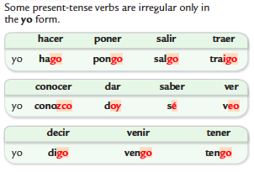

Irregular Preterite Verbs:
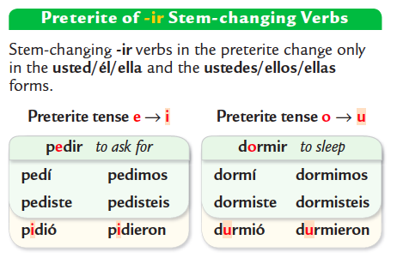
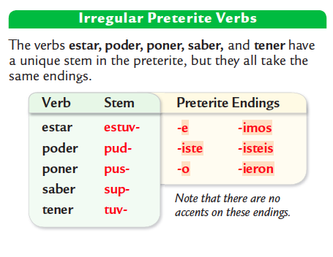
Hace que + Time:
Hace _____________ que ________________ = How long you have been doing something for
present tense
amount of time

Hace _____________ que ________________ = How long ago you did something
preterite tense
amount of time

5. Cultura:

Vocabulario Importante:
- Taíno: Native tribe of Puerto Rico
- Boricua: a person from Puerto Rico
- un timbal: a drum
- el vejigante: folkloric character in Puerto Rican celebrations, wearing brightly colored ornate masks.
- un desfile: a parade in the streets
- una máscara: a mask
- indígena:an indigenous/native person

Datos generales y geográficos:
- Capital of Puerto Rico: San Juan
- Typical food: tostones, pernil, arroz con gandules
- Geographical form: an island
- Surrounding sea: Caribbean Sea
- Countries to the West: The Dominican Republic
- Countries to the South: Venezuela (South America)
- Currency used:_US Dollar
- Official languages: English and Spanish
- Puerto Rico is an associated free state or commonwealth of the US. They maintain their historic and cultural identity while still being US citizens.
- Puerto Ricans do not vote in US presidential elections or pay property taxes to the US government, but they do have a congressional delegate (though the delegate cannot vote).
- Flag: red, white and blue

Los centros comerciales:
- Plaza Las Americas is the largest mall in The Caribbean
- Plaza Las Americas is located in San Juan, Puerto Rico
- It is decorated with art that represents the naturaleza (nature) and la historia (history) of Puerto Rico.
- Jockey Plaza the largest mall in Lima, Perú, named after the nearby horse track.

El arte histórico:
- José Campeche is the first well-known painter of Puerto Rico.
- He painted primarily religious works (obras) and portraits of political figures of the 18th century (siglo XVIII).

Información general
Los Timbaleros y la música:
- A timbalero is a person who plays drums and timbales are drums.
- Styles of music heard during festivals: bomba and plena (also salsa & folk music)
- The use of percussion instruments by the timbaleros serve as a reminder of the African heritage of the island.
El Morro:
- A famous example of Spanish architecture in San Juan is El Morro.
- The Spanish began building el Morro in 1539 to defend the island.

Los Taínos:
- Another name for Puerto Rico: Boriquén and Puerto Ricans: Boricuas
- Taínos are the indigenous (native) people of Puerto Rico. These names come from a Taíno word for Puerto Rico.

Los vejigantes:
- Los vejigantes are people who wear traditional Puerto Rican masks.
- You can see them in Ponce during carnaval/parades.
- The masks are painted bright colors and made of coconut shells (cáscaras de coco) or
Paper maché.
- Los Vejigantes can be mischievous during parades trying to scare people.
- Los Vejigantes appears during carnaval en Ponce and the festival of St. James (la Fiesta de Santiago Apóstol) in Loíza Aldea
- During these celebrations, musicians play bomba, a style of dance music with African roots.
- During the celebrations, Los Vejigantes dance and begin songs which people respond to with a rhyme.

Las artesanías:
Las artesanías de Puerto Rico:
- Two traditional types of Puerto Rican handicrafts are Las Tallas and Las Casitas
- Las tallas de santos are carvings of saints, made of wood
- Las casitas are miniature façades (front of building) of famous houses and buildings.

Las artesanías de Panamá:
- Molas are large brightly-colored fabrics made by los cunas, an indigenous community of Panamá.
- In the town of La Arena, artisans make ceramic pieces using sand from the area that are unique.

Las parrandas:
- Las Parrandas are groups of people walking through the streets during the Christmas season (temporada de Navidad).
- They sing Christmas songs and play traditional instruments, often until dawn.
- Sometimes they stop to sing at a friend’s house to surprise them and wake them up. This is called asaltos navideños.
- Some songs request food and drink.
- The family invites the parrandas in to eat and celebrate and then joins the parranda to repeat this tradition with another family.

