Nombre: __________________________ Bloque: ________ Fecha: _________________________
Chapter 3 – El tiempo - Weather

Asking About The Weather:
In Spain:  *¿Qué tiempo ___________________?  (What’s the weather?) | In Latin America:  ¿Cómo está el ___________________?  (What’s the weather?)
General Conditions:

- Hace ___________________ ___________________. (It’s good weather.)
- Hace ___________________ ___________________. (It’s bad weather.)
- La __________________________ es de ….. grados. (The temperature is ….. degrees)

Temperatures:
  - ___________________ ___________________. (It’s hot.)
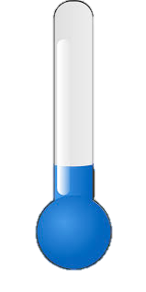
  - ___________________ ___________________. (It’s cool (temperature.))
  - ___________________ ___________________. (It’s cold.)

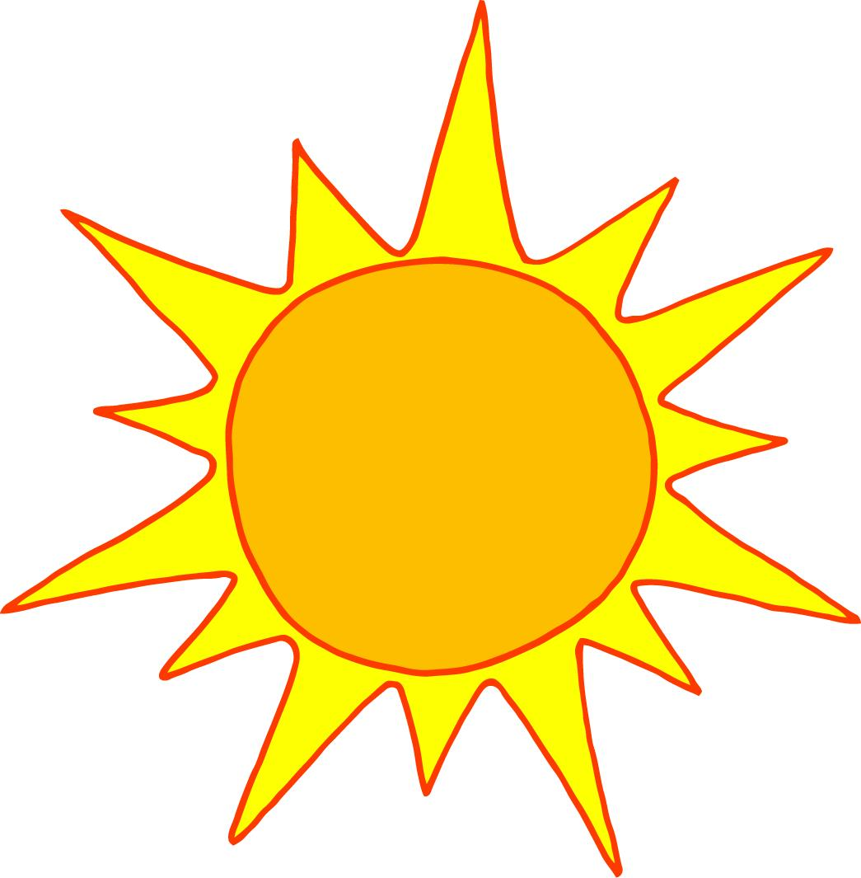
Conditions:

- ___________________ ___________________. // Hay sol. (It’s sunny.)
- ___________________ ___________________. (It’s windy.)
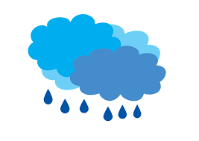
- ___________________ ___________________. // Está nublado. (It’s cloudy.)
- ___________________. // Hay lluvia. (It’s raining. // There is rain.)
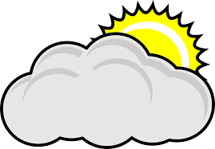
- ___________________. // Hay nieve. (It’s snowing. // There is snow.)
- Está parcialmente ___________________. (It’s partly cloudy.)
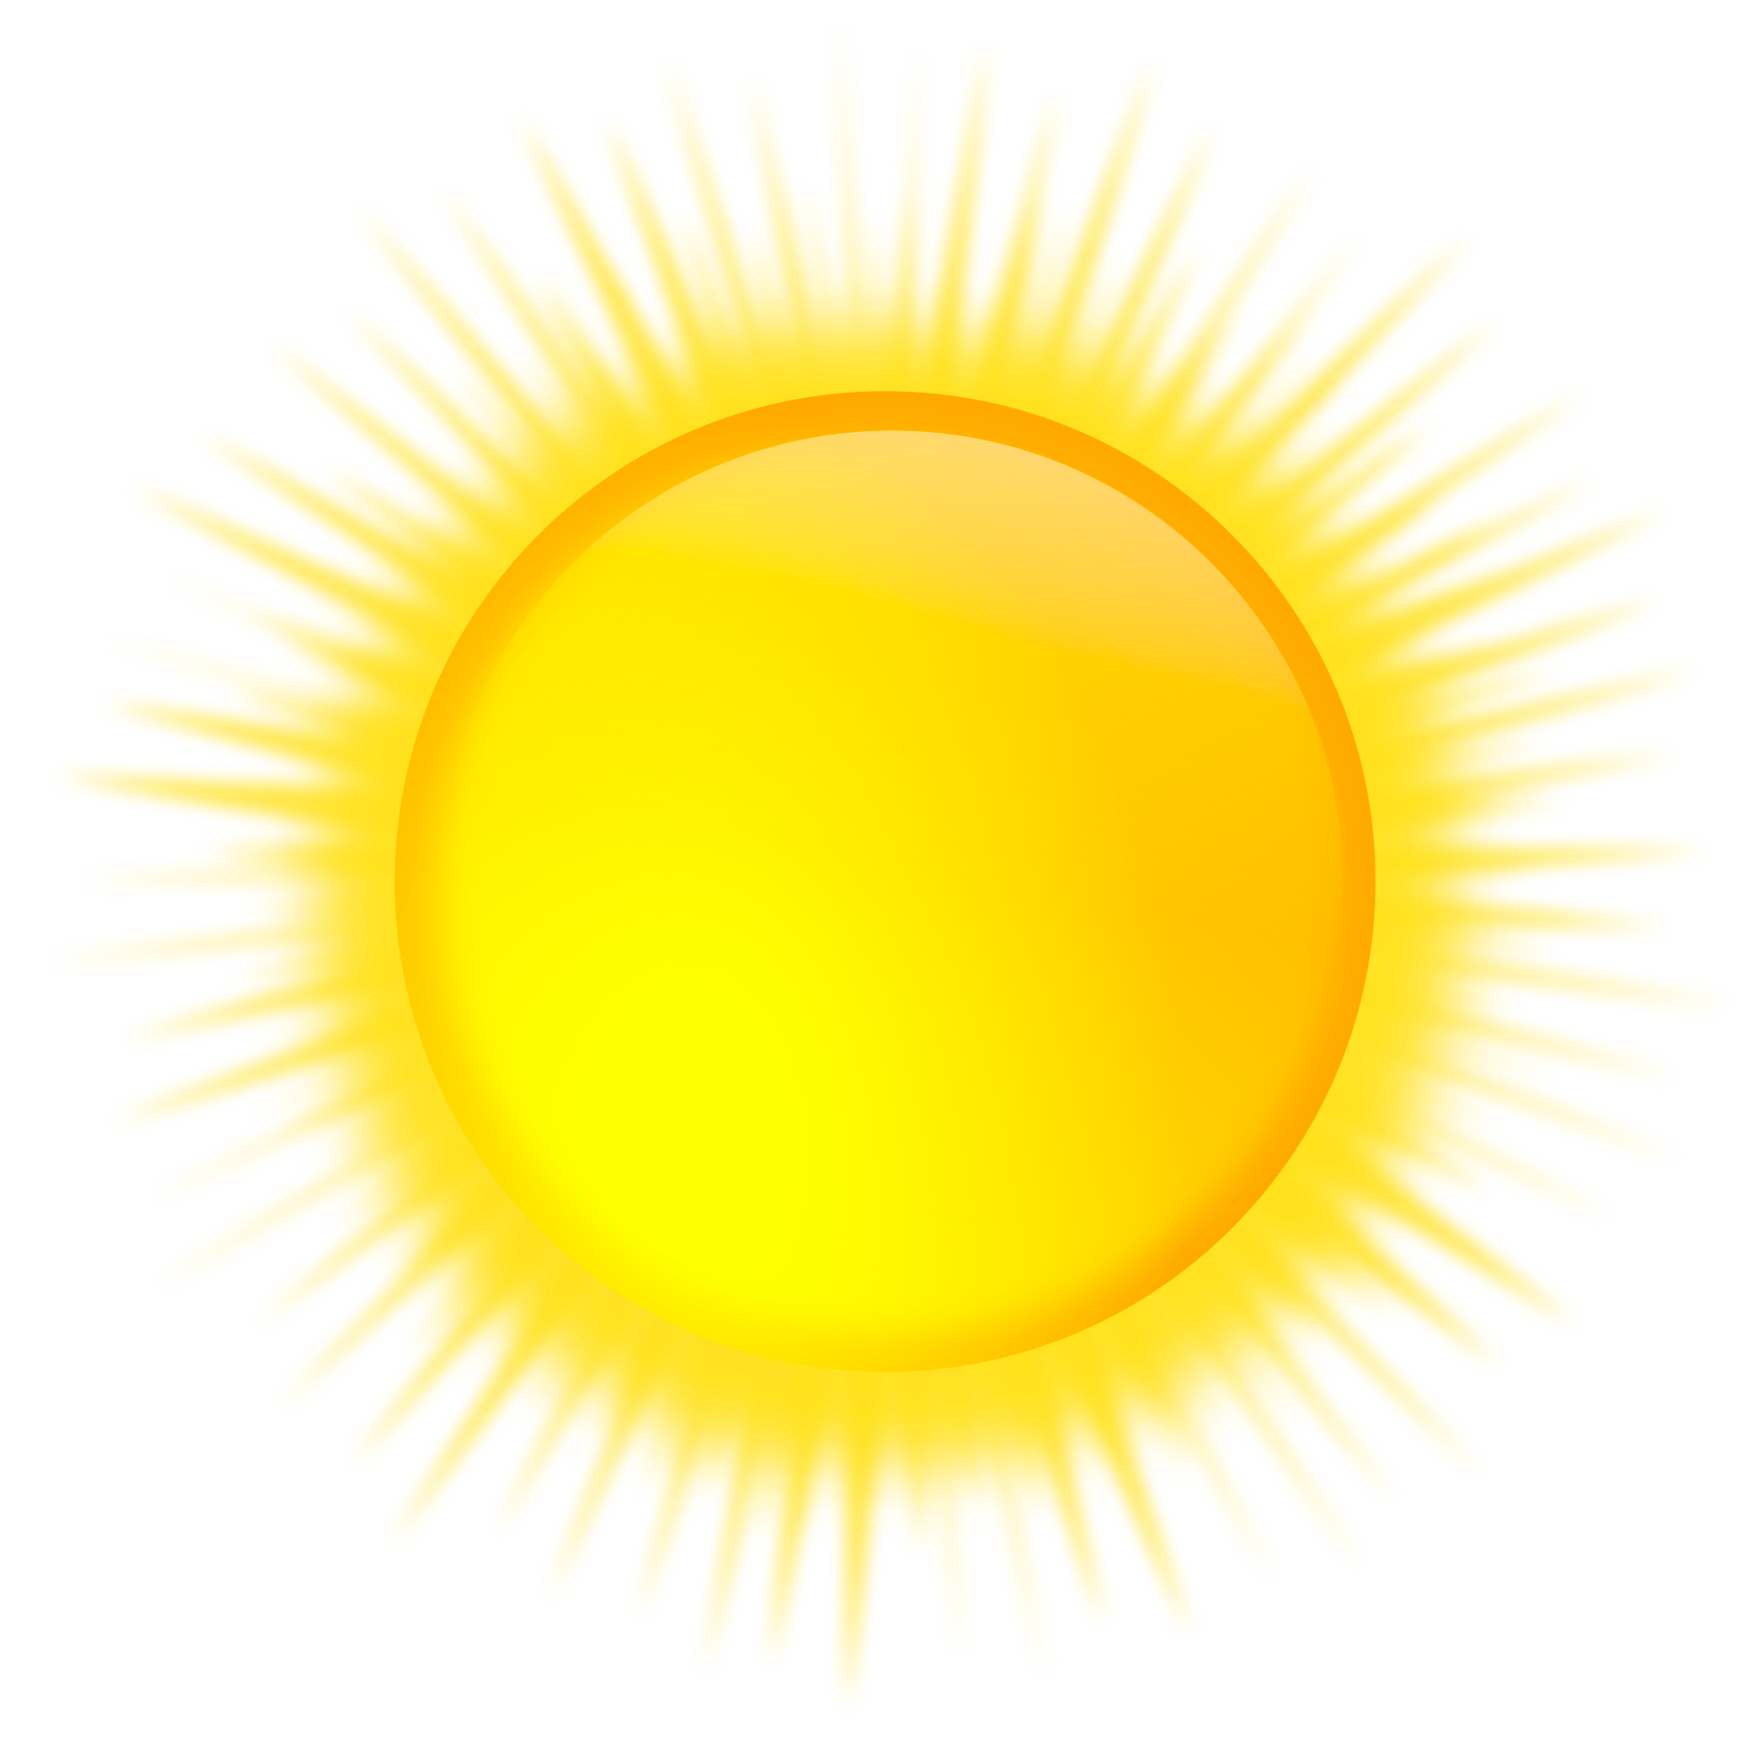
- Hay ________________________. (There is a moon.)
- El sol _____________________. (The sun is shining.)

