Nombre: _____________________ Bloque: ______ Fecha: _____________________
Capítulo 1
Repaso - Worksheet 3

A. Match the phrases with their meanings.

- ¿Cómo te llamas? _______
- ¿Cómo estás? _______
- ¿De dónde eres? _______
- Yo soy _______
- Él _______
- Ella _______
- Ellos _______
- Buenos días _______
- Adiós _______
- Hasta luego _______
- Goodbye
- I am
- She
- How are you?
- See you later
- He
- They
- Where are you from?
- What is your name?
- Good day/morning

B. Find the subject and verb in each sentence.

1. Yo soy de Puerto Rico. Subject : ______________ Verb: _____________

2. Ella es mi mejor amiga. Subject : ______________ Verb: _____________

C. Write the time for each clock.

1. 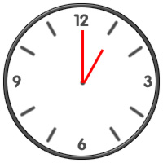 _______________________________________________________

2. 2:00 __________________________________________________________

3. 3:10 __________________________________________________________

4. 5:15 __________________________________________________________

5. 6:50 __________________________________________________________

