Nombre: _______________________ Bloque: _______ Fecha: ______________________
La cultura – Costa Rica – La comida
Costa Rica has several options of food, many of them are native, and others are very similar to those of neighboring countries. Costa Rican dishes are not highly seasoned, and are made basically of rice, black beans, vegetables, beef, chicken, and fish, and are usually served with corn tortillas.
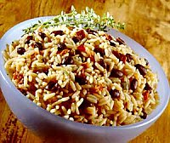
Costa Rica Breakfast:
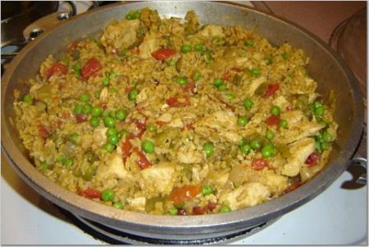
The characteristic breakfast of Costa Rica is gallo pinto (pinto/speckled rooster) that consists of rice and black or red beans mixed with onions, red pepper, cilantro, and spices. Usually it is served with eggs (scrambled or fried), natilla (similar to sour cream), and bread. Some people like to include fried ripe plantain.

Costa Rica Rice:
Rice is used with all the traditional dishes in Costa Rica and is also mixed with several ingredients in various meals. For example: arroz con pollo (rice with chicken) is very popular and it is frequently found as a main course at parties and in homes. This dish is so typical of this country, that international chains have incorporated it into the menus that they offer daily.

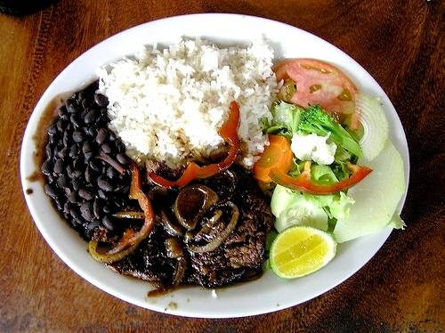
Costa Rica “Casado”:
A typical lunch dish is casado, which is a dish made of chicken in sauce served with rice, black or red beans, fried ripe plantain, salad, and mashed potatoes. Sometimes eggs and avocados are added.

Costa Rica Tamale:
Tamales are made of seasoned corn meal (sometimes mixed with mashed potatoes). Inside they have rice, green beans, carrots, and meat. Some people also add garbanzos (chickpeas), plums, and olives. The tamale is covered with plantain leaves and cooked by boiling cook it.

Other traditional foods:
Another dish that is considered very traditional, is olla de carne” a soup made of vegetables like chayote (a type of squash), yucca, potatoes, and other veggies, with the main item being cubed meat and bones.
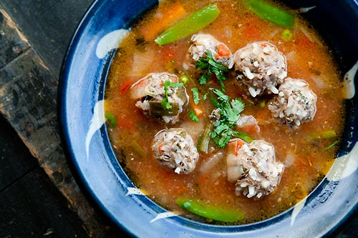
Mondongo soup (cow belly), albondigas soup (meatballs made with corn flower and eggs), and picadillos (diced with chayote, green plantain, and others) are common foods from Costa Rica and are very popular with visitors. Also, guisos (stew), refried beans, chicharrón of pork, and embutidos (cold cuts), that are offered usually with corn tortillas on the side or folded in the tortillas as a taco.

Source: http://www.tourism.co.cr/costa-rica-art-and-culture/costa-rica-food-and-cuisine/costa-rica-food.html

Reading Questions:

- Which food from Costa Rica would you like to (or be willing to) try?

- Which food seems similar to something you have eaten before or food you normally eat?

- Which food do you think sounds the most different from what you normally eat?

